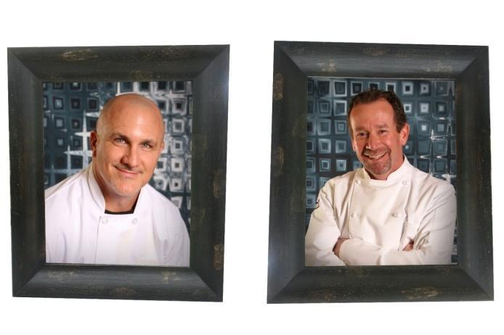
Classic Buffet Wedding Menu
Passed Bites/Stations – priced per selection
Sweet Thai chili cauliflower wings – 5.5 per guest

Smashed blackberry and chevre toast – crisp crostini, vanilla, mint – 4.25 per guest
Mac n cheese shot – Bacon – 5.5 per guest
Bourbon chicken skewers – Knob creek bourbon, garlic, honey, soy – 4 per guest

Grilled chili lime shrimp skewers – fresh lime and cilantro – 8.5 per guest

Coconut and lemongrass steak skewers – ginger, garlic, coconut milk – 7 per guest

Seasonal vegetable cup – edamame hummus – 3 per guest
Charcuterie - 13.75

La Fiesta - 10 per guest
Street Taco Bar

Mini corn tortillas, carne asada, grilled chicken

Refried beans & Spanish Rice

Condiments – cilantro, limes onions, red salsa, green salsa, tortilla chips

Mi Amore - 20.5 per guest
Choice of Caesar or Garden salad
Fresh baked artisan dinner rolls and butter
Tuscan chicken penne – sun dried tomatoes, spinach, cream, parmesan

The Adventure Begins – 24 per guest
Choice of Caesar or Garden salad
Fresh baked artisan dinner rolls and butter
Grilled chicken with lemon and thyme
Sides – Choice of 2
House pilaf – orzo, thyme, garlic
Yukon gold mashed potatoes
Oven roasted reds and rosemary
Oven roasted seasonal root vegetables
Garlic parmesan roasted broccoli

Honey butter roasted carrots

“I Do” – 26.25 per guest

Add grilled chicken with lemon thyme - 6 per guest
Choice of Caesar or Garden salad
Fresh baked artisan dinner rolls and butter
Roasted garlic tri tip
Sides – Choice of 2
House pilaf – orzo, thyme, garlic
Yukon gold mashed potatoes
Oven roasted reds and rosemary
Oven roasted seasonal root vegetables
Garlic parmesan roasted broccoli

Honey butter roasted carrots

Happily, Ever After – 56 per guest
Passed Bites/Stations – choice of 2
Spicy pork skewer
International cheese and farmer’s market
Mini burger with aged cheddar
Petite Italian meatballs in marinara
Smoked tri tip sammi with chimichurri sauce
Coconut and lemongrass steak skewers – ginger, garlic, coconut milk
Prosciutto wrapped Italian breadstick
Seasonal vegetable cup – edamame hummus
Mac n cheese station – pulled pork, crispy bacon, sautéed mushrooms, and jalapenos
Bruschetta station – Tomato basil, roasted peppers, marinated artichokes, fresh mozzarella, olives, fruit

Salad – choice of 1
House signature – arugula, roasted beets, crumbled feta, walnuts, citrus vinaigrette
Classic Caesar – crisp romaine hearts, crunchy croutons, parmesan
Bread- Fresh baked artisan dinner rolls and butter
Main Course – choice of 2
Chicken
Creamy lemon thyme chicken
Paprika chicken – boneless chicken thigh, chickpeas
Meat
Award-winning fennel boysenberry pork tenderloin
Chianti braised short rib
Fish and Seafood
Grilled shrimp skewer with chili lime glaze

Pepita crusted salmon – ancho chili powder, cumin, avocado oil
Grilled swordfish with tomatoes and oregano
Vegetarian/Vegan
Quinoa, feta and pistachio stuffed acorn squash
Sides-Choice of 2
Steve’s mac n cheese

Oven roasted seasonal root vegetables

Honey butter roasted carrots
Buttermilk boursin mashed potatoes
House pilaf – orzo, thyme, garlic

Beverage station – Infused water, lemonade, and fresh brewed iced tea
Cake cutting
Set up, serve and breakdown food and beverage stations
Platters and buffet serving utensils

Additional Services

Beverage station – 2.25 per guest
Infused water, lemonade, and fresh brewed iced tea, disposable cups
Coffee Bar – 3.50 per guest
Decaf & regular, creamer, sugar, paper drink cups
Cake cutting – 1.5 per guest
Includes high quality disposable fork and plastic plate
Bartender Service - 250
One Qualified and Experienced Mixologist, professional bartending tools & equipment, one hour pre-start set up, up to four-hour service time
Client to supply to supply all alcohol, beer, wine, champagne, mixers, garnish, beer, wine, cups, ice, straws
Serving Staff – 175 each
Tray pass appetizers
Set up, serve and breakdown food and beverage stations
Table bussing
Rental Items
China plate, goblet, 3-piece flatware – 3.25 per
Champagne flute - .85 per
Cloth napkin – 1 per
Dinner plate - .85 per
China Dessert Plate and fork - 1.50 per
Bride & Groom Send Off Meal – 23.5 per
Vendor Meal – 50% of guest pricing
Bridal Party Bites – 75 per 12-inch grazing tray
Delivered to bridal cottage prior to ceremony
Man Cave Munchies – 85 per 12 inch grazing tray
Delivered to the man cave prior to ceremony
Gratuity, Administration Fee and Tax not included

