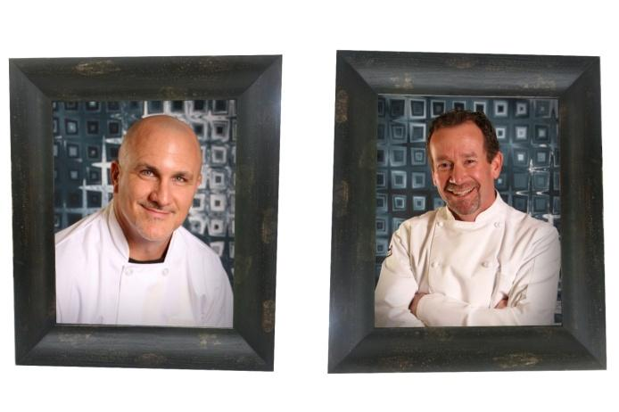

HOLIDAY MENU

Appetizers – priced per selection
Turkey meatballs in a cranberry BBQ glaze $4
Prime rib bruschetta - crusty bread, fig and thyme aioli $5.25
Roasted cranberry and goat cheese flatbread $3.75
Figs with walnuts and gorgonzola $4.25
Brie, apple and honey crostini $3.25
Charcuterie $13.75
Brown sugar chili glazed pork belly lollipop $4.75
Sweet bacon wrapped chicken bites $4.25

Salads-choice of 1 included in price of entree
Arugula, apple and pomegranate salad. V
Fall harvest quinoa salad, butternut squash, apple, cranberries, almonds, pepitas-cider vinaigrette
Berry pistachio spinach salad

Entrée-choice of 1
Roasted creamy lemon and thyme chicken $24.99
Bourbon honey baked ham $22.99
Chianti braised beef short rib $29.99
Rosemary garlic peppercorn roasted prime rib of beef - $52.99
Fennel boysenberry pork tenderloin $24.99
Herb roasted turkey breast $19.99
Quinoa, feta, pistachio stuffed acorn squash $19.99

Sides-choice of 2 included in price of entree
Loaded scalloped potatoes – cheddar and bacon
Sailor Jerry’s spiced sweet potato marshmallow casserole. V
Cherry pecan wild rice pilaf
Boursin cheese infused mashed potatoes. V
Honey roasted butternut squash with cranberries and feta. V
Cauliflower goat cheese gratin
Autumn spiced roasted carrots with pistachios. V
Brussels sprouts with pancetta and rosemary
Roasted green beans with garlic, lemon, pine nuts and parmesan Reggiano

Selection of holiday dessert available

All entrees include:
Freshly baked dinner roll and butter
High quality disposable plates, cutlery, cups and napkins

